Questionnaire Results

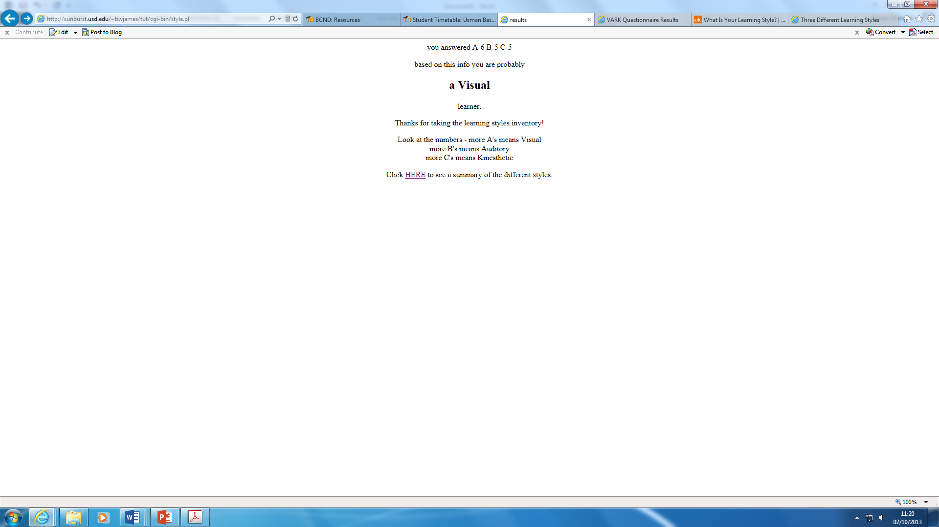

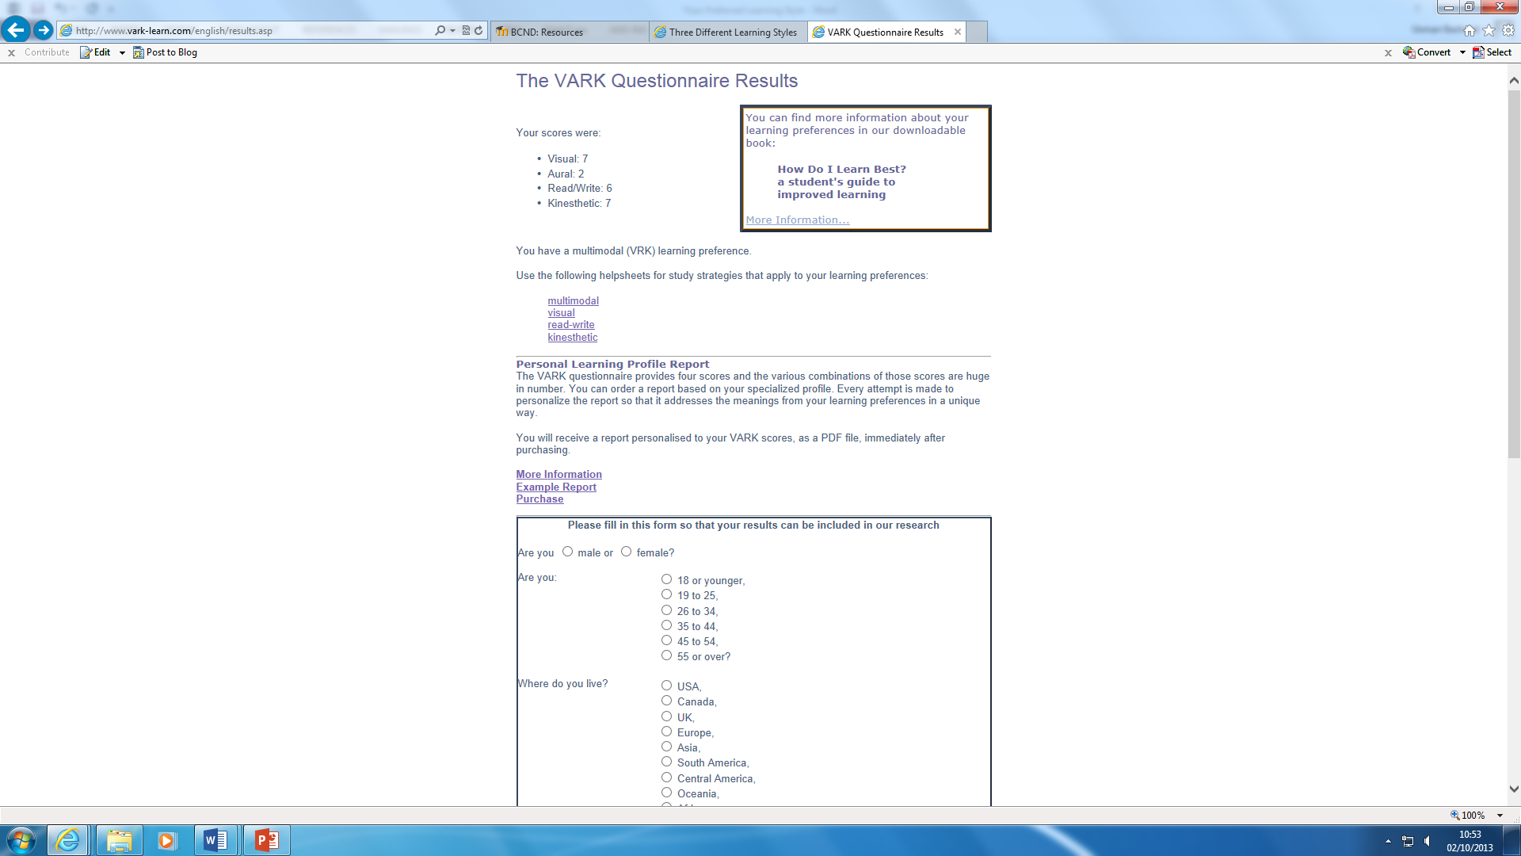

# M3

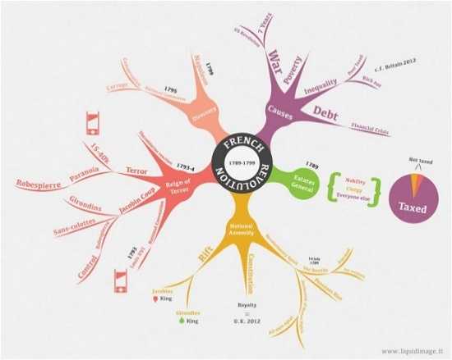The following report I am going to mention, they are all types of ways which people find their own unique way of learning. Some people can be one of them, all of them or two of them. . I am going to explain each of the following definitions with some examples.

* ***Auditory***
* ***Kinaesthetic***
* ***Technology***
* ***Social***
* ***Solitary***
* ***Visual***

# Different types of learning styles

**Auditory** means it could relate to the process of listening. Whilst listening, they find it easier as it could stick into the user’s mind. For example the spelling of dog, they could remember it as a song. Therefore, it becomes fun and easier to remember how to spell the word. However, some people find listening to videos quite useful, as they can remember specific scenes of the videos.

These are some of the following examples:

* Discussions in class
* 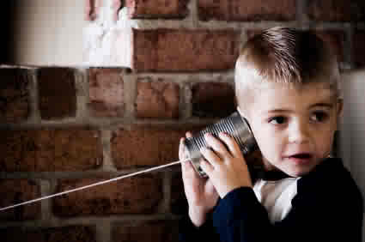Recording the class notes rather than writing it down and repeatedly listening to it
* Videos
* Using a song to memorise a particular definition

These users have good memory. They can remember particular words and phrases at the right time

**Kinaesthetic** means love ‘to-do’ things. They like to participate in physical activities such as;

* They want to move around a lot whilst they learn something new.
* Experiments
* Role plays

They can’t just sit and listen. They want to try the new product out physically. Also, they move a lot.

Lastly, **visual** means they like to ‘see’ things. For example, they like to make notes rather than participating in any discussion. They can remember these notes whilst making each sector of it a different colour. Some examples could be:

* Diagrams
* Cue cards
* Different colours for different sections in their notes
* Films

This is easy, because in an exam if a question comes up, they can remember the colour coding of that topic.

**[](http://www.google.co.uk/url?sa=i&rct=j&q=&esrc=s&frm=1&source=images&cd=&cad=rja&docid=-qS4DHjIZTReVM&tbnid=xS-5qjG9kW_dVM:&ved=0CAUQjRw&url=http://www.transcel.com/technology.aspx&ei=wdpTUrvqIseN7AaogYGoAQ&bvm=bv.53537100,d.ZGU&psig=AFQjCNGOLM436akJfKqBnSzfgztI5gqGvg&ust=1381313599434211)Technology**- Many people use technology to learn new things. For example, if they don’t know the spelling of a word or the definition of the word, they can search the word up and look at the definition. They don’t use the hard copy of the dictionary. If they need any help with spelling issues or definition problems they can go search on the internet. Some people not only find definitions to learn, they can read or research any interesting facts.

**[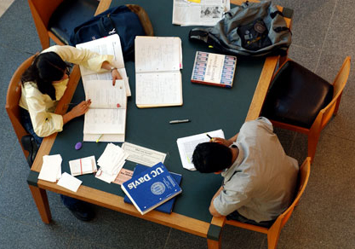](http://www.google.co.uk/url?sa=i&rct=j&q=&esrc=s&frm=1&source=images&cd=&cad=rja&docid=7NxVux-bwqZlWM&tbnid=51DVwTa-yBjNNM:&ved=0CAUQjRw&url=http://studenthacks.org/2007/11/08/group-study/&ei=vSJVUuVDo7jsBrqigcgI&bvm=bv.53760139,d.ZGU&psig=AFQjCNGJNGUtE3ds5SGCv0ffWbGPcUZB0w&ust=1381397511978294)Social learning** is when a group of friends gather together and study whilst bringing each other’s notes together. They study in groups with friends so if they each stuck on a particular subject, they can help and learn from each other by solving a particular problem. Also, they can test each other to see what they have learnt. This comes in useful as they can help each other. Mainly, pupils go to the library as there is peace and quiet to concentrate on their work.

**Solitary** learning is when pupils prefer to work alone and self-study. They like to prefer to work individually, and they know where there mind works well. They work peacefully away from all the distractions and noises. Some examples can be:

* Putting the notes on a desk and work independently
* Privately
* Organised

# Why does knowing your learning style benefit you?

Knowing my learning style is important, because it can prepare me when I revise for a test. Therefore, my learning style is a bit of all; Kinaesthetic, Visual and Auditory. It can tell me which way learn best so I learn best by putting put diagrams it helps me revise. For example in year 11, I had a mock test and I hadn’t revised for it. It was the day of the exam and I went through the notes that I had left. I revised only for 20 minutes and I got a B for that exam. I was thankful that I had made the notes from before, because it helped me out by revising last minute.